**SQL DDL Quiz**

**Question 1**

Why should you define primary key constraints when creating the database tables in the database management system?

* They enable the database to enforce the uniqueness of the key.

**Question 2**

The command to remove the CUSTOMER table from a database is:

* *DROP TABLE CUSTOMER;*

**Question 3**

Consider the following table:

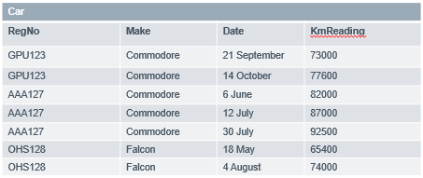

Which data type is most suitable to declare the attribute RegNo?

* *CHAR*

**Question 4**

Consider the following table:

|  |  |  |  |
| --- | --- | --- | --- |
| StaffID | StaffName | Gender | PhoneNumber |
| B658 | Walter Nicolas | M | 998456234 |
| B584 | Olivia Thompson | F | 992548136 |

Which constraint is would be useful in this table?

* Gender CHAR CHECK(Gender IN(‘M’,’F’))

**Question 5**

Consider the following SQL statement:

*CREATE TABLE SUPERHERO(*

*HeroID number(4),*

*HeroName VARCHAR(40),*

*Gender VARCHAR(10),*

*Age NUMBER(2),*

*);*

Superheroes cannot be underage because of the dangerous work they do. Which of the following statement ensures the Age field does not allow values under 18?

* *Age NUMBER(2) CHECK(Age > =18);*

**Question 6**

Consider the following MEMBERSHIP Table definition:

*CREATE MEMBERSHIP(*

*ClubID VARCHAR(3),*

*HeroID number(4),*

*Position VARCHAR(40),*

*JoinedOn DATE,*

*PRIMARY KEY(ClubID, HeroID),*

*FOREIGN KEY(ClubID) REFERENCES CLUB,*

*FOREIGN KEY(HeroID) REFERENCES SUPERHERO*

*);*

Which of the following is **not** correct?

* The primary key is incorrect because it includes foreign key fields.

**Question 7**

The Department table has an attribute budget which would store values such as this (6235467893.45) which of the following data types should be used to declare budget?

* *NUMERIC(12,2)*

**Question 8**

An attribute A of data type varchar(20) has the value “Avi” . The attribute B of data type char(20) has value ”Reed” . Here attribute A is ____ characters long and attribute B is ____ characters long.

* 3,20